FOR IMMEDIATE RELEASE
[Date]

Contact: Name, email address
Phone number

[NAME OF COMPANY] JOINS THE MICHIGAN BATTLE OF THE BUILDINGS

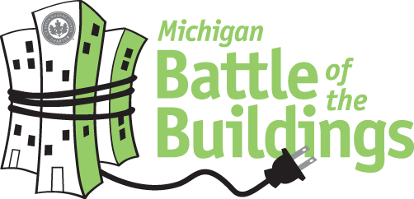

[YOUR CITY], Mich. – [NAME OF COMPANY] has entered [SQUARE FOOTAGE] of building space in the Michigan Battle of the Buildings.

Made possible by strong community partners like the West Michigan Chapter and Detroit Chapter of the US Green Building council, Consumers Energy, and DTE Energy, the Michigan USGBC Battle of the Buildings program is an awards and recognition program for energy use reduction open to all commercial buildings. The program is a way to encourage energy-efficient practices in buildings across the region and to instill a spirit of friendly competition among the area’s building owners and operators. The buildings that demonstrate the greatest percentage-based reduction in EUI (energy use intensity) during the competition will be recognized as a winner at the 2017 energy summit. This summit will consist of a panel discussion of participants, exhibit booths, and an awards banquet.

Throughout the competition [NAME OF COMPANY] will cut energy waste through energy-saving activities such as making improvements to the building, optimizing operations and maintenance, and engaging occupants to save.

[INSERT quotation from company principal: Why is this competition significant. What energy reducing changes will you be making?]

Established in 19__, NAME OF COMPANY specializes in ___________. For more information, visit www.nameofwebsitehere.com.

# # #

